COSMIC SCHOOL SUPPLEMENT
By ThornyMu (GigglingVoid) and Pure-Interest1958 V1.0



While most people don’t relish the idea of being a child again, at least not if they are being treated like one and made to go back to school, it can’t be denied that there are a great many worlds where jumpers wind up either back in school or in a school adjacent educational facility for the world their in. We are thus offering you the chance to own and design your very own private school. Use this supplement when you are in a Jump and attending or teaching at a school. Following the Jump, it will become an attachment to your warehouse and may be imported to any future Jump where you might make use of such a school.

MODES
This Supplement functions much like an Alt-Warehouse, allowing growth across Jumps, but is in addition to any Warehouse you have. The grounds may not be used to store excess Warehouse ‘stuff’.

Pick a Mode

Canon School Mode
You will start with the school of your current setting. Each Jump where there is a School, you merge your school with the existing one. The new merged school will retain the canon staff, attitudes and student body, and will possess any unique features of the school, such as the Grom and Grom Night tradition from Owl House. You may choose to retain these features going forward. To add more features yourself, you can convert CP or jump equivalent points into School Points (SP) at a 1:4 ratio, or take a drawback for the school. You gain SP for every Jump in which you have the Drawback active. Anything purchased can have SP spent on it across multiple jumps, but you do not receive it or remove it until the full price has been paid.

Morphing School (- 50 SP)
Requires Canon School Mode
Rather than just replace the school of a setting, your school copies the appearance of an existing school in a jump before replacing it, gaining that appearance as one you can swap it between in future jumps. At each Import you can choose which appearance to use, and during the jumps you may have it slowly morph between appearances over a 10-year period (or slower if you desire).

Custom School Mode
In this mode, your school is inserted into the setting in an appropriate area near to your starting location as its own school. You may change the name and adjust the general appearance in line with what you have purchased each jump, or spend 3 months remodelling it for 50 SP every ten years. You receive 500 SP to customize your school and can convert CP or jump equivalent points into SP at a 1:4 ratio, or take drawbacks for the school. You gain SP for every Jump in which you have the Drawback active. You also receive 50 SP for each jump or gauntlet you complete where you attend the school for the majority of your time there either as a student or staff, or graduate from the school during your time there. Anything purchased can have SP spent on it across multiple jumps, but you do not receive it or remove it until the full price has been paid.

School District Mode
Perhaps you don’t want to design every detail of each school you collect -- you don’t want to work out the points, you just want it as presented in the Jump you found it in, and you want the next school, and the next. Each as separate buildings. From now on, a copy of any schools or other educational facilities you complete attendance at or retain employment at can be collected as attachments to your warehouse. You can import these schools into future jumps, and spend SP to upgrade them. CP may be converted into SP at a 1:4 rate, and each school will gain 20SP each Jump you import it into that can only be spent on that school. Drawbacks are also applied on a per-school basis, providing SP for that specific school.

GENERAL MODIFIERS

School Quality
This will determine the general quality of your school’s facilities and equipment

- Horrible (+200 SP)
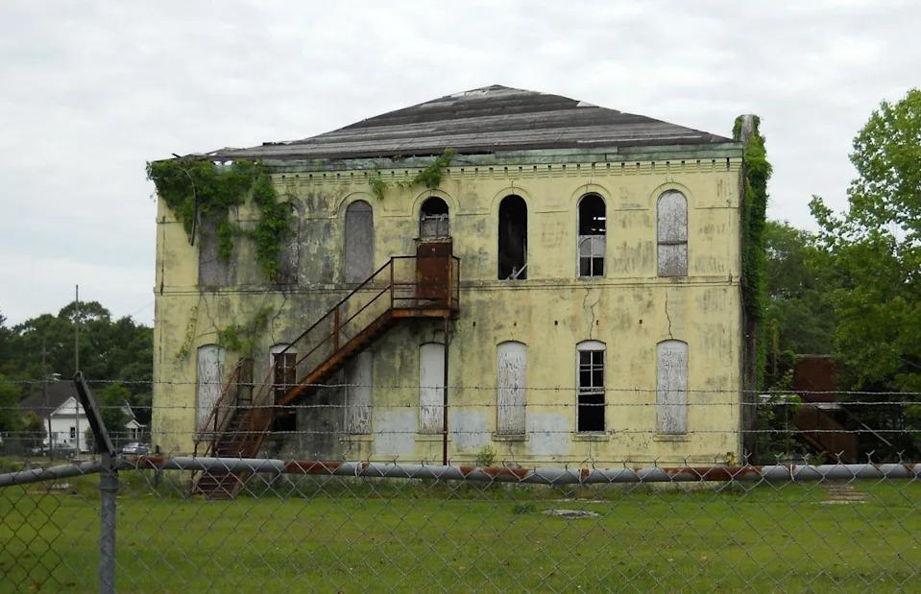
At this level, your school is barely managing to keep functioning between outdated and faulty equipment. Buildings that leak, have mold and other health hazards. Funding is constantly drying up to pay for things and other issues that plague your school. This level of school quality also limits your maximum staff quality to poor.
- Poor (+100 SP)
Your school is generally considered to be one of the last choices that someone might to attend. The buildings will be cracked and drafty. Equipment will be cheap and may have issues with their quality control.
- Standard (Free)
Not the best school out there, but far from the worst. Your buildings will generally be a mixture of portable/pre-fab structures and brick buildings.
- Good (-100 SP)
Your school is one a lot of people are interested in attending as the buildings will typically be solid construction and the equipment and facilities will be if not the best options out there, at least reliable alternatives.
- Prestigious (-200 SP)
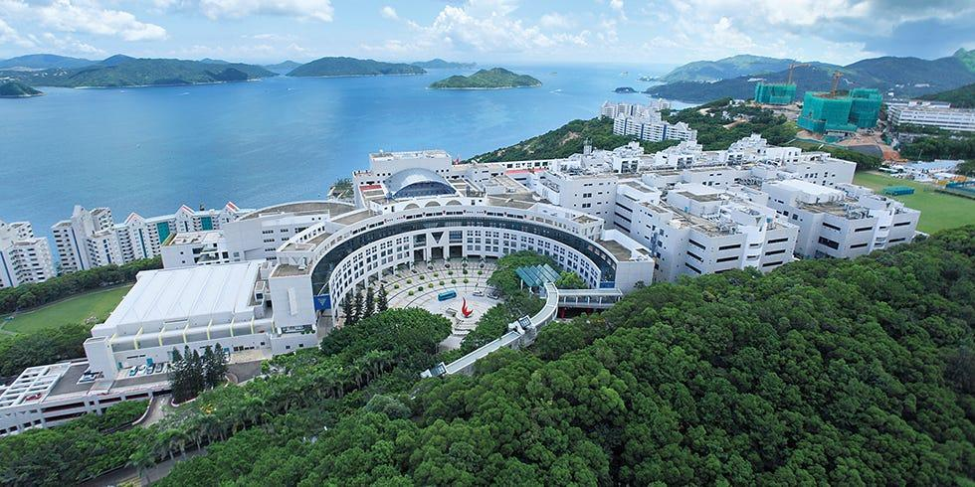
The school is seemingly free from budgeting concerns, with top of the line equipment and facilities to teach its students. These items will be if not the newest models then items with fewer unnecessary features, traded out for solid and reliable products that can stand up to the beating a student who doesn’t care about it may dish out and still be reused the next year for a new crop. This level limits minimum staff quality to good.

NPC Staff Quality
Your school will not keep the original staff once you Jump. You may purchase NPC replicas that will be copied into your warehouse, only capable of performing their purchased staff duties. You may use normal hiring methods to hire real people to replace the NPCs with higher quality staff, possibly acquiring Followers willing to travel and teach across dimensions. If none of these options are taken, then your school will entirely lack any staff that you do not provide from outside.

- Erratic (+200 SP)

Your staff are not just unmotivated and have little grasp of what they are teaching, but they can’t even be relied on to turn up. If they do, they might do so dressed in a dinosaur costume and spend the day talking about how the earth is really flat, and the moon landings were faked to your science classes. Alternatively, like the gentleman on the left, they might have no training or knowledge of the subject at all and merely have gotten the job because their name is Professor Duck.
- Poor (+100 SP)
Your staff don’t really know much about the subject or how best to teach it but will generally show up and at least read the text book to the class that may be paying attention.
- Standard (Free)
Your staff have passed any required teaching courses and at least make an effort to keep the class from acting up in courses.
- Good (-100 SP)
Your teaching staff are well-educated and motivated to teach the students.
- Expert (-200 SP)

Your teachers aren’t just well-educated and motivated, but knowledgeable in how to get the students to engage and think about the course work, forming their own opinions and retaining the knowledge.

DEFAULT SCHOOL
Unless your Mode specifies otherwise, the school you receive from this supplement focuses solely on an academic curriculum from kindergarten to year 12 and needs to look outside its walls for a sporting field and other benefits. The items here can be purchased to upgrade your school.

SCHOOL CURRICULUM
These options focus on the type and nature of the classes offered to your students and will apply to any purchases made in Expanded education.

General Education (Free)
Your school teaches math, history, and politics of your current world, reading and writing in the local language, and at least some form of basic art and music.

Wide Curriculum (-100 SP)
Your school offers a wide range of courses for students including things like pottery, metal working, other local languages, cooking, life skills, etc.

Special Education (-200 SP)
Your school has facilitators and teachers trained to properly educate students with special needs, ranging from cognitive and physical disabilities to (if appropriate for your other options) supernatural drawbacks.

Gifted Education (-200 SP)
Requires Wide Curriculum
Your school has facilitators and teachers trained to properly educate students with special powers such as the ability to use magic or superpowers if they are widely known and accepted in the setting, such as wizarding courses in a Dungeons and Dragons world. Unlocks the Science-Fantasy Section.

Secret Education (-400 SP)
Required Wide Curriculum and Secret School or Hidden Campus.
If supernatural forces or abilities exist in your world but are generally hidden from the public, such as magic in the Harry Potter world, your school may gain programs to teach students capable of its use and the facilities to hide that education from the outside world. A secret school is able to teach its students this knowledge with no risk of it being found, if the school has a mixture of those with powers and those without via hidden campus, however there is the risk of regular students discovering what is really being taught in those exclusive clubs and classes.

Expanded Education
These buildings add to the degree of education available and transform your school into an academy. The options here will combine with other modules purchased here to generate suitable variations for the form of education purchased. For example, if you purchase a school cafeteria and university then the university will have a number of food shops, vending machines and possibly a bar. If you purchase a preschool and library, it will have books focused on basic alphabet or bedtime stories to be read to children.

Preschool (-200 SP)
Your school now has day care and early education facilities for children too young for normal classes, giving them an extra head start in both social skills and school discipline.

Higher Education (-200 SP)
Your school now has the facilities and staff to offer courses in some form of higher education. Each purchase adds another course category. Whether this be college courses, university courses, technical trade courses or some other mundane variant suited to your world and country.

SPORTS FACILITIES
These may be bundled together into a common Sports facility, such as a race-track around a soccer field, or distributed across your facilities.

Pool (-50 SP, -100 SP)
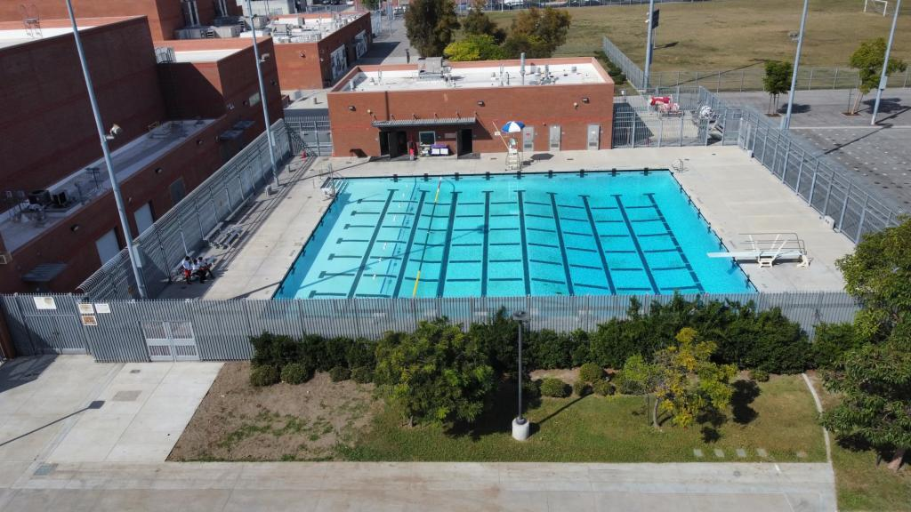
For 50 school points, you receive a 25-meter pool and fence to keep people from drowning in it. For 100 school points you instead receive a 50-meter pool with its own dedicated change rooms, storage room and a spare room that can be used by a swimming team or club, and lifeguard stations.

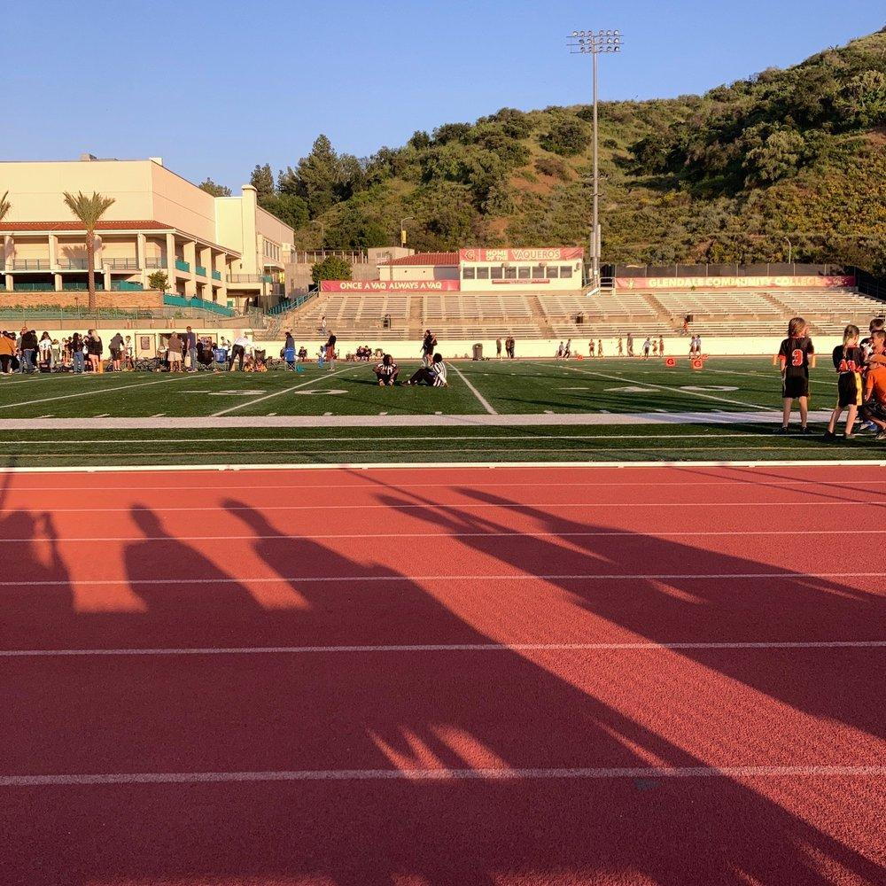
Track (-50 SP)
Each purchase provides one form of outdoor exercise facility such as the eponymous Race Track, a pair of Tennis courts, or even a Quadrangle amidst your campus buildings.

Field (-50 SP)
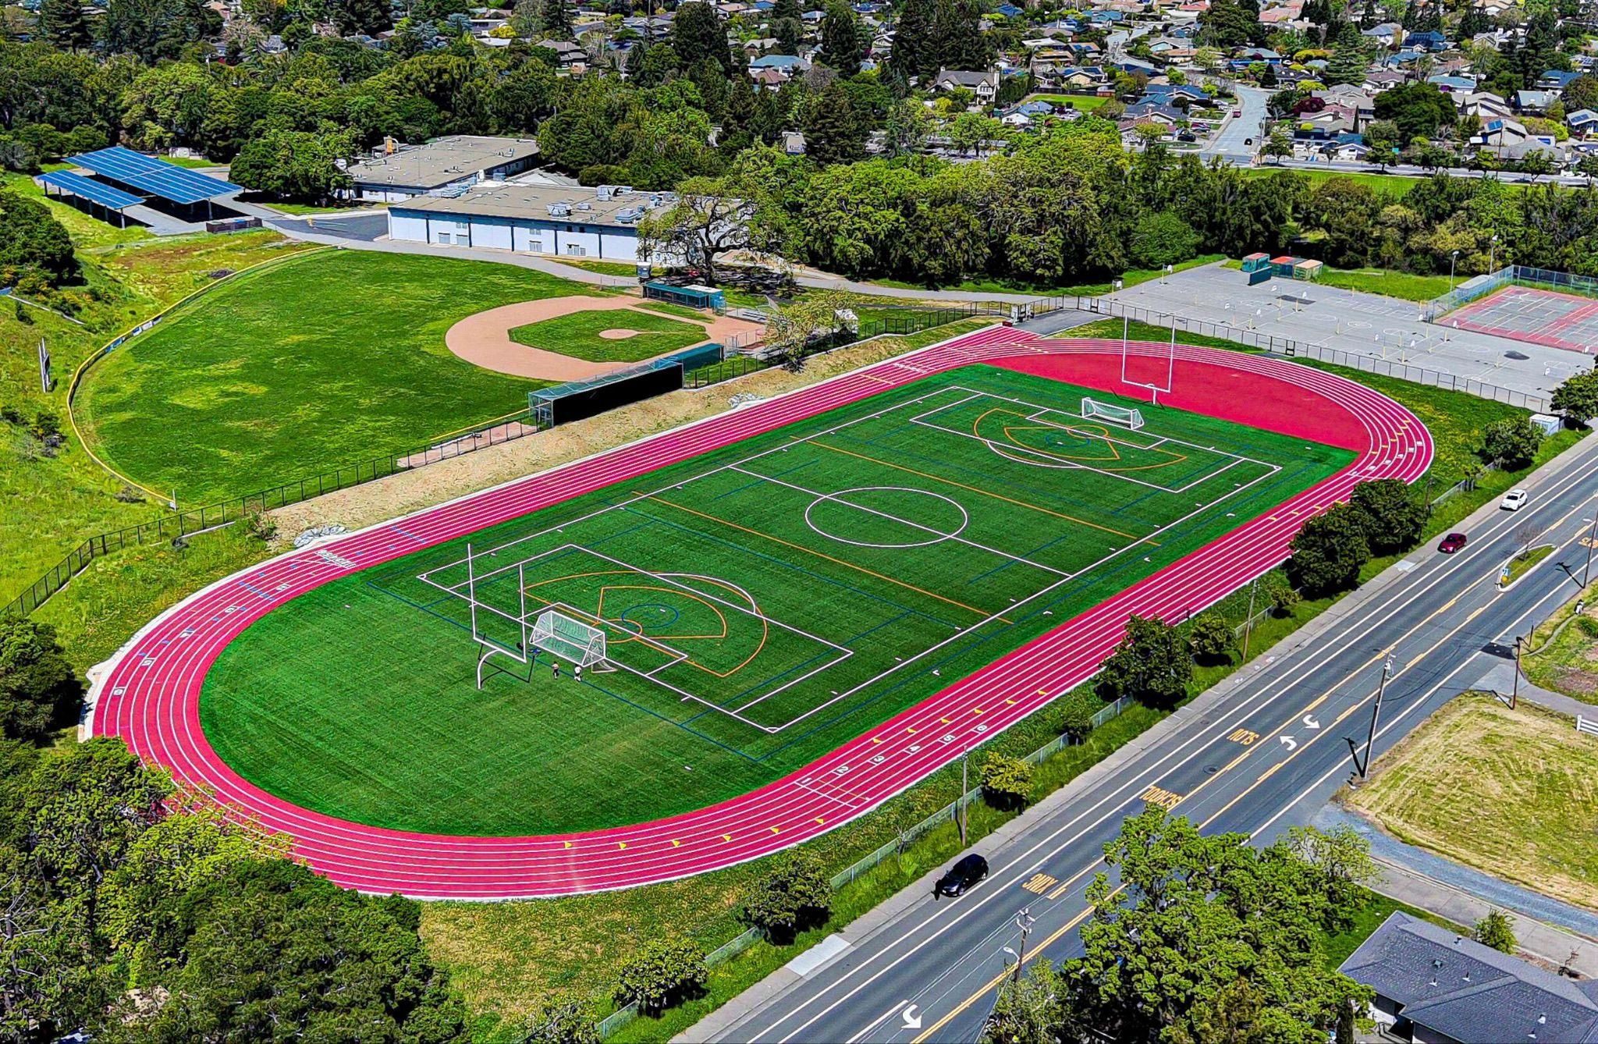
Each purchase provides a field for more sports such as American Football, Football (Soccer), Baseball, Cricket, or Lacrosse. You can even construct a golf course, one purchase per Hole.

Gym (-50 SP, -100 SP)
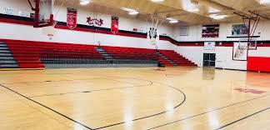
You receive exercise facilities consisting of a large court that can be used for physical education and indoor sports. For 100 SP in addition to the main court area, the gym will include specialized areas for strength training and cardio.

SCHOOL BUILDINGS
These buildings will increase the facilities and options available in your school.

Auditorium/Main Hall (-50 SP)
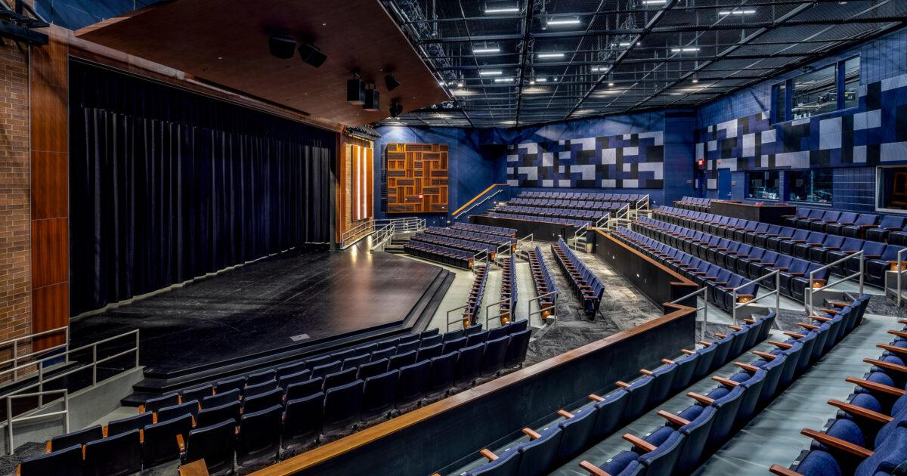
Each purchase provides a large building for school assemblies, concerts, and plays by drama club, or upgrades your existing one for more impressive events.

Library (-50 SP, can be purchased multiple times)
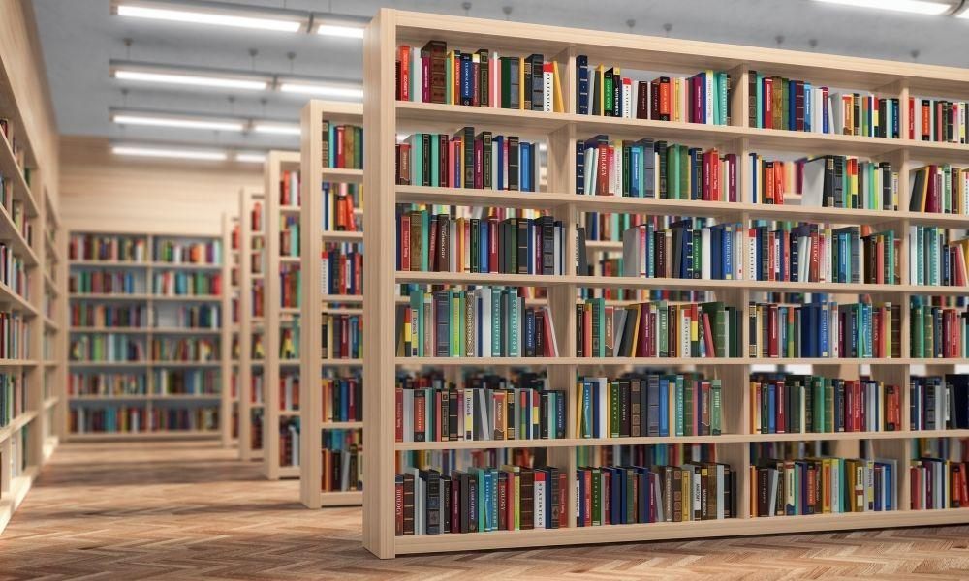
For 50 you have one general school library. Each additional purchase can be used for two purposes. Firstly, you can purchase additional libraries such as one for primary school students and one for high school students with different books and some research resources in the older students’ library. Secondly, you can use this to increase the size and prestige of the library, adding a dedicated section for a given subject matter.

First Aid (-50 SP, -100 SP)
For 50 SP the school has a dedicated first aid room with a bed, defibrillator, first aid kit for treatment of students. For 100 SP the first aid room is upgraded into a nurse’s office with 2 beds, more equipment and a fully trained nurse on-site.

Cafeteria (-100 SP, -200 SP)

For 100 school points, the school now has a small shop that sells food for school lunches. Although it doesn’t offer a wide variety of food, it will have drinks, packets of chips, some fruit and hot food such as meat pies or sausage rolls. If you spend 200 school points, this upgrades to a proper cafeteria with its own chairs and tables for students to sit at while having lunch. This level will have a rotating menu of pizza, burgers, chicken nuggets, and pasta, along with mandatory components like fruits, vegetables, and drinks as well as vegetarian and other dietary options if notified of a student's needs in advance. The menu is planned to provide a balanced and generally healthy meal.

Fleet Support (-100 SP)
Transporting students and staff from events can become quite expensive. But you now have a series of stables, garages, or hangers appropriate for any vehicles your school requires, flavored to the local setting. This includes the Staff and supplies necessary to maintain these vehicles. Unless you purchase Transportation, these vehicles are only for Staff use, not for students such as school buses.

Dormitories (-150 SP)
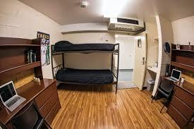
Living arrangements that allow the school to function as a boarding school. Quality of the living arrangements is based on Quality of the School. Typical student accommodations allow for two students with space to complete their schoolwork and store clothing. Higher tiers of school quality will reduce the number of students sharing laundry and washing facilities, while lower tiers will increase them. Prestigious quality dormitories can have entire rooms with ensuite for single students in the higher grades. Dormitories are typically segregated by gender and will have an adult of the same sex living there as well to serve as a chaperone.

Off Campus Facilities (-150 SP)
Each purchase adds a property owned and operated by or on behalf of the school. These specialized properties facilitate hands-on courses in subjects like agriculture, horseback riding, construction, or marine biology. Students will provide local service at a discount while a knowledgeable instructor observes and corrects. The service fees are used to help off-set the cost of materials during the students' education. In each Jump, these facilities will be imported as appropriate.

Computer lab (-200 SP)
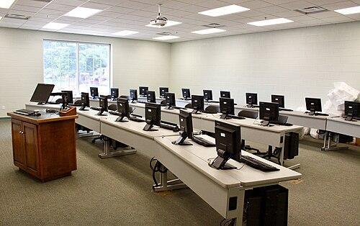
Your school has a dedicated classroom, server racks and courses involving computers, computer programming and other IT fields. If Quality is at least Good, then students will each have their own drives to work from. Greatly benefits from Internet Hub.

Science Block (-300 SP)
Rather than just a science course here and there, your school has dedicated rooms for physics, biology and chemistry, complete with the larger equipment such classrooms would require to allow students to perform proper research.

SCHOOL UPGRADES
These are general upgrades that don’t deal with specific buildings or classes but will offer an overall upgrade to the quality of life for those attending your school or your school's appearance and reputation.

Demonstration School (Free)
Your school is used for people studying education to do work experience and teach classes. During your first Jump some of your teachers will be students themselves, and students may be subject to experimental teaching methods. In subsequent Jumps, your NPCs will be able to train up real people to teach. Some of them will be willing to remain at the school once their education is complete.

7 Mysteries (Free, -100, +100)
Your school possesses 7 mysteries that students whisper to each other about. These could be entirely mundane and real things like a hidden corridor from one part of the school to another, grisly and spooky things like a closed dormitory where someone murdered all the people living there or even outright magical things like a girls change room that only women can enter and any man attempting entry is turned into a girl or an umbrella that appears randomly and cause two people who share it to fall in love. By default, one neutral mystery is true. Every beneficial truth costs -100 SP, while each negative truth gains you +100 SP. Lies are free regardless.

Customizable (-10 SP)
Every Jump, you may customise the look of the school to better fit within that setting's aesthetics. Functionally, your school does not change in any meaningful way.

Green School (-10 SP)
Your school is worried about the environment, or at least wishes to benefit from the subsidies available from an environmentally sustainable footprint. It has solar panels on the roof, double-glazed windows and improved insulation to help with heating and cooling. The lighting is LED lighting rather than fluorescent. The toilets and shower blocks all use low heads and double flush buttons (two buttons, one is a half flush for peeing while the other is a full flush) fed by a rainwater barrel on the roof. The plants are all chosen to be draught resistant or suited to the local environment with minimal water care.

Locker Rooms (-10 SP)
Your school will have sufficient change rooms and toilet blocks for all its students. In addition, each student will have their own locker where they can store school books, a change of clothes and other minor items for their own use.

Parking (-10 SP, -25 SP)
Your school now has parking for the teachers’, students’, and visitors’ private vehicles. For 10 SP, this is just a couple of small parking spaces primarily intended for staff and visitors, though there may be a dozen or so for students who get there early. For 25 SP this provides a full scale 3 story car park with 151 spaces that staff can reserve and students can pay for a year's use, as well as a number of spaces reserved for visitors such as parents.

Exchange Students (-25 SP)
Your school attracts students from other countries and has programs for sending students to experience other cultures too. There may even be a Cultural Exchange center that holds events.

Founders (-25 SP, -50 SP)
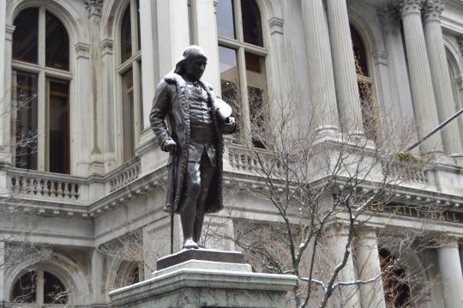
Your school now has a nice little plaque somewhere like the administration block listing your name, as well as any Companions you would like listed, as the founders of the school with a suitably old founding date for the setting whether this was a few years ago for a newly established colony or several hundred or even thousand years ago if the setting has been in existence a long time. For an additional 25 SP, you can also have your likeness cast in bronze with a suitably impressive statue of yourself somewhere on school grounds. Alternatively, if you prefer, it could be a humbler statue of your first class of students or some other commemoration of your school's founding.

Elevator System (-50 SP)
Your school has unified the progression from kindergarten through to university under a common pedagogy, with higher priority given to internal progression over outside applicants. This streamlines the experience for students who stay within your education system.

Administration Block (-50 SP)
This portion of the school has been dedicated to the staff responsible for running it. There will be an office for the principal, vice principal, a front desk with a secretary responsible for handling calls from parents and payment of school bills as well as a meal room where the teachers can get away from the kids for a while and a group office where they can handle their own paperwork.

Internet Hub (-50 SP)
Depending on the quality of the school, you have some degree of Internet/Intranet. At lower levels, it’s very slow and maybe only connects across your own school. At higher levels you not only have ports in every desk, you have campus wide Wi-Fi with blazing fast speeds with your school having the fastest internet or equivalent for the setting connection available.

Segregated School (-50 SP)
You may create special criteria for your school. Perhaps your school is for boys or girls only, alternatively coed but with the two sections separated. Perhaps you only allow students from specific species or tribes. Can’t be taken with “Public School”.

Partial Scholarship (-50 SP, -100 SP)
Your school provides a number of partial scholarships in athletics or academics (-100 SP for both). Works well with “Full Ride Scholarships”

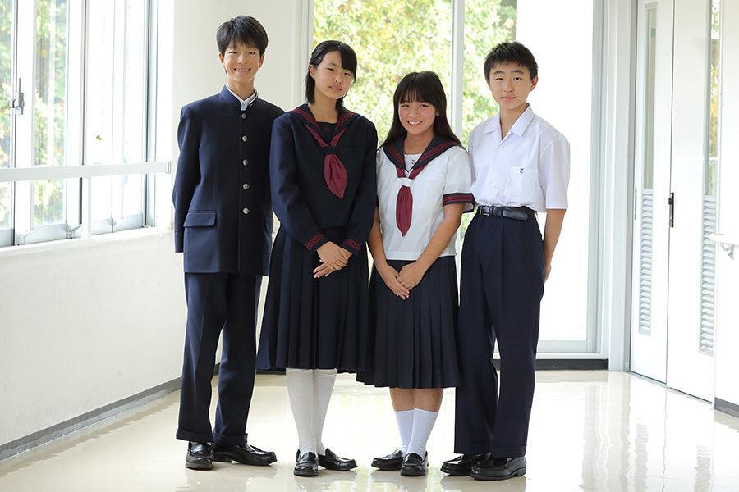
Uniforms (-50 SP, -100 SP)
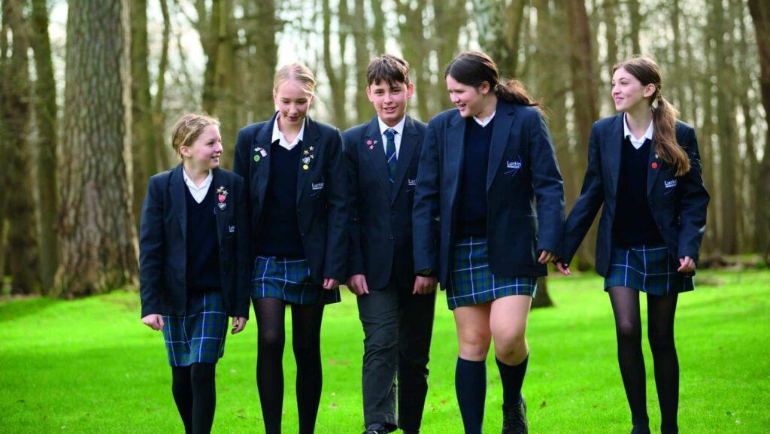
Your school now has its own uniform that the students are required to wear when attending school or school related events such as field trips as well; as variants for things like sports, summer and winter periods, or to distinguish particular grades such as a variant for primary, middle and high school. These uniforms promote equality, reduce bullying by minimizing socioeconomic status displays, and enhance safety by making students easily identifiable. They also foster a sense of community and discipline, reduce distractions, and simplify the morning routine for both students and parents. While helping prevent gang-related activities and creating a more focused, professional, and inclusive learning environment for all students. The benefits of these uniforms remain even after a student graduates if they wear it for activities such as studying or preparing a presentation for work, though they might get odd looks if they wear them in the office. If you pay 50 SP, then the students are required to purchase and wear the uniforms. If you pay 100 SP, a mysterious Alumni has fully subsidized the costs and all uniforms are provided free of charge. Either way, you may design the details of the Uniforms, or opt for the standard Japanese ‘Sailor’ or European ‘Business’ Uniforms.

Full Ride Scholarships (-100 SP)
Requires at least 1 purchase of Partial Scholarship.
Your school has enough donations to afford several full ride scholarships in addition to the lower level ones. You may set the criteria and amounts every jump and on purchase.

Gnomes (100 SP)
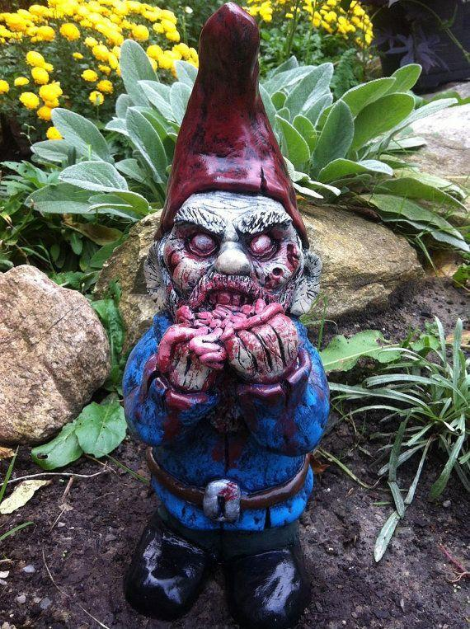
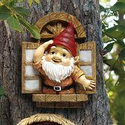
These little lawn gnomes are scattered around the school, almost like hidden easter eggs, with many generations of students whiling away an idle afternoon trying to spot the ones hidden in the strangest places. No one knows who takes care of them, but every now, and then they seem to change places or have new ones appear while old ones disappear. Unlike normal gnomes, they might be on a building or seemingly living in a tree. The truth is, however, these gnomes are actually magical constructs that tend to the school at night when no one is there; cleaning, repairing, and generally taking care of all the maintenance required. Of course if someone were to steal one, or heaven forbid, kick or destroy it, they will find their life taking a turn for the worse with school work mysteriously destroyed, lockers graffitied and other petty, but not lethal or even seriously cruel, punishments until they make up for their transgression. The gnomes may take on a more disturbing appearance during this time period.

School Excursions (-100 SP)
Students are able to go on school trips to edutainment locations like science centers or nature walks, class trips to other cities and countries.

Transportation (-100 SP)
Your students have access to free and reliable transportation too and from the school back to wherever they live. The available tech will determine how far away it is reasonable for your students to live and still attend.

Upgradeable (-100 SP)
Your school will retain modifications and improvements made through jumps. These must be functional in the Jump they are made and will be Fiat-Backed to keep working. Without this, you can make upgrades, but they will be reverted to the limits of your Fiat-Backed purchases (which can come from other sources) at the end of the Jump.

Campus Security (-100 SP, -300 SP)
Your school has an NPC staff of security personnel and the facilities to properly monitor your campus grounds. For an extra 200, your security is as strong as a small country's military. Their actual quality will match that purchased above.

Educational Aura (-200 SP)
Your school possesses an aura that makes learning new subjects and skills easier to achieve. Any attempt to learn here is twice as effective as it would be elsewhere.

Public School (-300 SP, -400 SP)
Your school is fully funded for any and all students to attend. This covers the facilities, all staff salaries, all regular classes, and some extracurricular activities. For an extra 100, this will also cover school supplies for all students and any of the non-standard courses and activities the school hosts. However, you must now accept all students in an area surrounding your school determined by the local government and can’t take “Segregated school”

IVY League Reputation (-300 SP)
Requires Prodigious Quality and Excellent Staff.
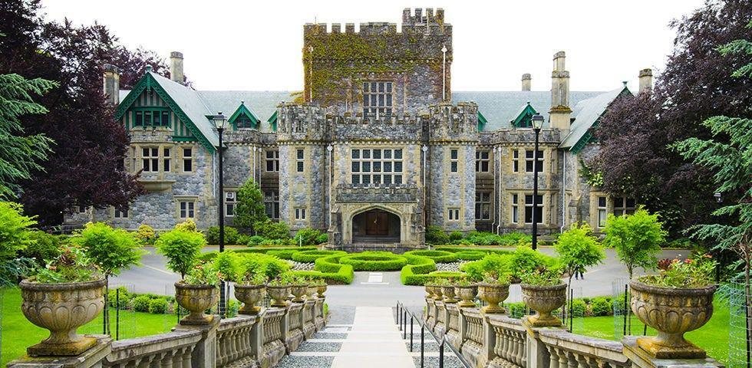
The campus is now spoken of in the same breath as prestigious educational facilities like Harvard, Yale, and Oxford (look up prestigious places in other countries) and graduation is considered proof of being an educated and intelligent person.

Secret School (-300 SP)
Maybe your school is a secret military academy, spy school, lewd enclave, or even a magic school in an otherwise mundane world. Regardless of why, your school has features to keep it hidden from the rest of the world, making it no longer subject to local laws, norms, or public scrutiny. This ensures that you can teach things not normally available in your current Jump world without throwing off all of society such as magic or advanced tech.

Military (-400 SP)
Your school is focused on, or gains a section dedicated to, a military education. This includes firearms safety, drills, and at higher levels, specialized modules focusing on the military usage of other courses your schools offer (electrical, computers, robotics, flying, etc.).

SCIENCE-FANTASY SCHOOL
By default, the Gifted Education Curriculum only allows the teaching of magic, super powers, and super science that is available to the current setting. The following purchases facilitate such education to continue in any world.

Hidden Campus (-50 SP)
Whether your school is officially a secret or not, your school utilises some method of non-natural hiding to protect portions of the campus from being discovered by some portion of the populace, or even from lower level students. Only those who qualify, by whatever metrics you choose, can find the hidden portions of the Campus. You may only hide the entire Campus this way if you have also purchased Secret School.

Mystery Fleet (-100 SP) Requires Fleet Support or Transportation & at least one Mana Crystal Core or Quantum Empowerment Field.
School vehicles are now all equipped with advanced capabilities, be they flying ships, stealth school buses capable of squeezing into narrow allies. Alternatively, you may use entirely non-vehicular methods of transport, such as teleportation or portals. If you are using physical vehicles, then each is equipped with an item providing a 25-meter radius of fiat-backing for anything the students can study at the school.

Simulation Facilities (-200 SP)
Your school now has advanced facilities to simulate particular environments and situations to allow a student to learn about them in safety. Such as seemingly standing in space observing a replica of the solar system and observing how moving and altering the planets and star affects the other celestial bodies. This might be achieved via a room that can magically create and destroy equipment, or a VR simulation achieved via suits and neural interface brains. This can also be used to simulate training in hostile environments without the fear of actual death or damage.

Sky High School (-200 SP) Requires at least one Mana Crystal Core or Quantum Empowerment Field.
As depicted at the start of this document, your school can now fly through the sky. It may be stationary or moving. If you have Secret School, then it may even turn invisible. If you have Hidden Campus then the school can deploy a field that will passively create a no-fly zone for any aircraft or other types of flight that will divert those you don’t wish to find, or crash into your school around it. This however only works on planned flights if someone is fleeing an enemy and not paying attention to where they’re going they may still stumble across, or into you.

Mana Crystal Cores (-200 SP)
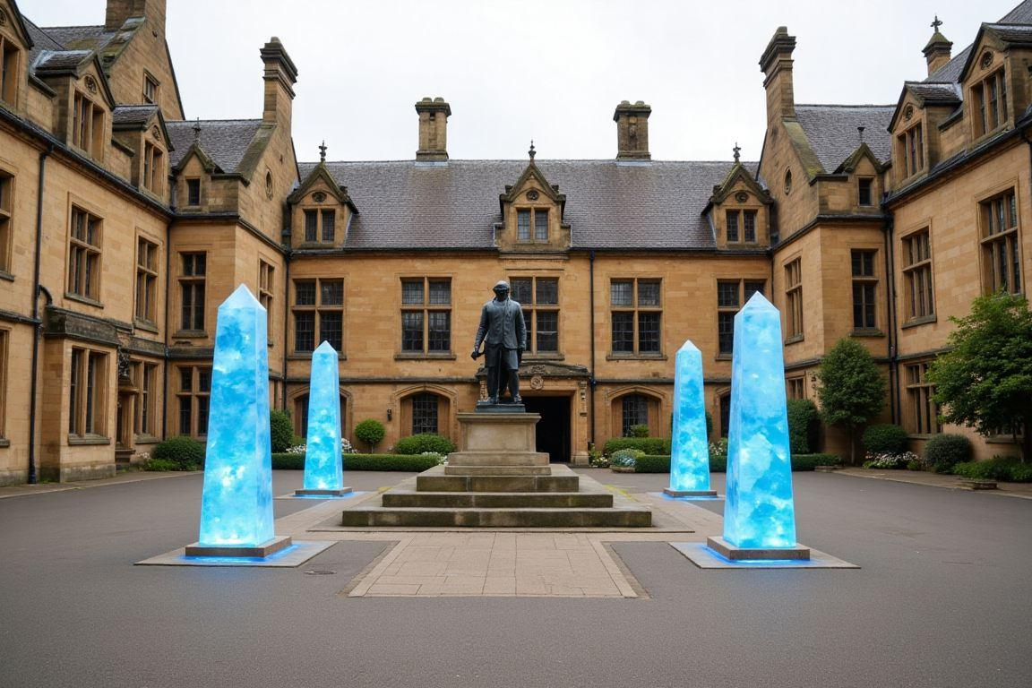
A massive crystal core, or several smaller crystals, are distributed across your school generating magical energy to provide access to a type of magic not normally available in your current setting. Each purchase allows you to attune your school to support one magical energy source (mana, aura, life force, qi, chi, curse energy, etc.) and magic system that would not otherwise work in that setting. Each Jump you may change which magic systems they are attuned to. Systems that are similar enough may be able to share a crystal, though this may limit the options of the one it wasn’t intended to support. This does not provide fiat-backing beyond the grounds of your school.

Mana Crystal Pendants (-100 SP/-10 SP) Requires Mana Crystal Cores.

Your students may be equipped with a pendant attuned to one of the Crystal Cores in your school, allowing them to draw on the power of the cores and perform their magic even while away from your school. Each pendant may attune to one core, plus extra Core per 10 extra spent.

Quantum Empowerment Fields (-400 SP)
Super powers and super tech tend to blend many lines. Your school can now support both, from any dimension. The QEF generates an energy field that alters local physics, allowing technology and powers such as the speed force or dilithium warp cores to work inside it. This can be used to replicate any metaphysics required for super science and super powers from any world you’ve already been to, but only across your campus. However, while it can be used to replicate the physics required for magic use it can’t provide the magical energy individuals require to cast spells, for that an alternative source such as “Mana crystal core” is required.

QEF Infusion (-200 SP) Requires Quantum Empowerment Fields for super powers or Mana Crystal Core for Magic.
Sometimes Pendants and vehicle based Resonator Projectors are not sufficient. To use abilities from other worlds on their own, your students will need to receive a QEF Infusion. This renders any super powers or magic they developed at your school to be fully Fiat-Backed.

Cosmic Fiat Infusion (-X SP)
If “Mana crystals” or the QEF doesn’t satisfy your desire to teach, as the individual is still limited to specific magic or power systems, then you can instead purchase the Cosmic Fiat Infusion. This Infusion will slowly alter the cosmic signature of a student at your school to grant them a fiat backed Perk you possess. This may be magic, flight, or chi use, just like the options above, but it can also include Charisma perks, narrative perks, and potentially even meta perks, so long as they do not conflict with your own existence here. The student will generate any required internal energies such as mana, no longer reliant upon the Mana Crystals. The Infusion is not enough on its own, it will require months or years of training to make the Perk a part of their cosmic self. About 10 days per CP (undiscounted).

It will cost you 10x the Undiscounted CP cost of the Perk in SP to be able to offer it at your school. For example, 1,000 SP will allow you to teach one 100 CP perk.

You may spend an extra 200 SP to allow Graduates to pass on the Infusion to future generations, as it directly alters their genetic structure like any other inheritable trait, such as blue eyes or green hair. The final tweak happens at the graduation ceremony so anyone failing to graduate will not be able to use or pass on these Perks.

This upgrade may be purchased multiple times to allow different abilities to be taught at the same time, such as JJK style Sorcery and Super Strength, if you purchased it twice and have both those Perks yourself. The Perk your CFI allows you to teach can be changed when entering a jump or every ten years.

QEF Resonator (-200 SP, -300 SP) Requires Quantum Empowerment Fields.
Super tech tends to blend many lines, and the QEF blurs that even further. This device can be built into any type of technological device in order to allow it to function as if it were fiat backed. The resonator has thousands of tiny runes inscribed on its surface and circuitry, as well as a hidden large rune in the brand logo itself. Altering any part of the resonator such as removing the logo will cause it and the associated tech to cease functioning. For 300 SP, the resonator functions like a power pack or external hard drive and can easily be plugged in or disconnected from a device to allow it to function. Without a resonator, attempts to duplicate your fiat backed technology and the physics it relies on will fail, with one your students can build wonders no one else in the world can duplicate.

DRAWBACKS
Of course, not all schools are a good place to be. Below are a number of drawbacks that can be purchased to provide you with more School Points each Jump to customize your school at the costs of issues you will have to find a way to work around.

Bad Neighbourhood (+10 SP)
Your school is positioned in a poor location. Perhaps you are downwind from the sewage treatment plant, or in the bad side of town with lots of crime and gangs.

Competitive (+10 SP)
School has an excessive competitive nature and students are often stressed and antagonistic towards each other, viewing other students as rivals for that top spot rather than a friend. Scores will be posted publicly.

Insufficient Staffing (+10 SP)
A mirror to overcrowding in your school, although the class sizes are reasonable, there just aren’t enough trained and experienced teachers available to teach them. This leads to students often being left unsupervised and expected to study much of the coursework themselves. Teachers may eventually be available to ask about anything they don’t understand. Or classes may be taught by teaching assistants and substitutes who don’t fully understand the subject themselves.

Limited funding (+10 SP)
Your school has limited funding which can result in larger class sizes, outdated resources, and fewer experienced teachers, resulting in a lower quality of education for students, higher dropout rates, and a widening achievement gap. Inadequate funding also means you may find yourself required to cut subjects of interest to the students that you simply can’t afford to fund, such as painting classes.

Overcrowding (+10 SP)
Your school is trying to crowd too many students into classes, whether this is due to a desire to save money by hiring fewer staff or just a lack of understanding on what an appropriate class size is. This can lead to increased stress for students and teachers, distractions in the classroom, more bullying, and a negative impact on academic performance and the quality of education.

Outdated Infrastructure (+10 SP)
For this Jump, the Quality of your School is reduced by 1 Stage per purchase. The buildings are older than they should be, wiring worn down, computers are of earlier models, VCRs instead of DVD players, cellophane projectors instead of computer screens; in general, things are reverted so that nothing has been kept up to date with your setting.

Public Obligation (+10 SP)
Due to the laws or norms of your society, your school is obligated to provide education for any and all students who qualify. If they are especially poor, you may be provided subsidies for them, but it will always be an extra challenge. Your school will be unable to cultivate a reputation of being in the Elite, and must provide the local curriculum, abiding by the local laws of your society. Negates IVY League while active. Can only be taken if your current world has a society capable of holding your school accountable to their standards.

Bullying (+10 SP, +20 SP)
Your school now suffers from large-scale bullying, leading to issues like depression, anxiety, and long-term health and social problems for many of the students suffering from an organized and deliberate attempt to isolate or humiliate them. In more modern schools, cyberbullying is also a major component. If you take this drawback at the 20 SP level then this is not just cruel bullying, but actual gang conflicts and violence flaring up which can put bystanders at risk either accidentally or through deliberate threats to keep them quiet. These gangs can be actual local gangs or groups of students from rival martial arts schools feuding and fighting on school grounds.

Natural Disasters (+10-30 SP)

Your school is located in an area that is subject to regular natural disasters such as flooding, earthquakes and droughts. This will result in property damage, student and staff trauma, loss of learning time, and infrastructure failures as the environment itself hinders your ability to study safely. You will need to develop emergency plans, conduct drills, and integrate disaster preparedness into your students’ curriculum and daily activities. As well as potentially making more resilient infrastructure and providing mental health support to help the community heal and recover after each event. Or you could just keep calm and carry on, though that might be risky. The severity of the natural disasters will range from mild and rare (for 10), up to severe or frequent (for 20), or both (for 30).

Creepy Crawlies (+20 SP)
Your school seems to be infested by pests and vermin, or perhaps ghosts. Regardless of what it is, they have been known to occasionally attack students. You will need to take extra precautions to keep these minor threats at bay. You may also have issues with the health department if you have a cafeteria as it won't be uncommon to see regular scurrying cockroaches, rats, and mice near it and if the food is not well protected it will often be infested or gnawed on.

Small School (+20 SP)
Portions of your educational structure are not functional for this Jump. Instead of providing K-12, you must pick one set that is still functional. Elementary (K-6), Middle School (7-9), or High School (10-12). If you have expanded into Collegiate level courses, then they are still functional.

Historical Registration (+20 SP)
Your school is heritage listed and changes are not allowed to be made unless they fit in with the era it was originally made (as presented in the current setting). You are likely to get tourists desiring to see the historical setting and hear the history of what has happened here. Negates Secret School while active.

Expensive (+20 SP)
Your school is quite expensive, vastly limiting who can afford to attend and reducing the number of students you can cover with Scholarships. Negates Public School while active.

Minimum Curriculum (+30 SP)
While your school still offers the core subjects of Math, Science, Language (this is the main language of your setting e.g., English, Japanese, Klingon, Elvish, etc. and covers reading, writing and otherwise using that language properly), a single Foreign or Secondary Language (one which is extremely common in your setting such as French, Spanish, Dwarven, etc.), Art, History, Health and Physical Education, only the bare minimum is taught. All electives and bonus course options are disabled while this is active.

NOTES

